App Dev Project Report

Student Details
Name: Pankaj Singh

Roll Number: 24f2002856
Email: 24f2002856@ds.study.iitm.ac.in
Repo Link: https://github.com/PANKAJ2998/mad2-project/tree/main/Placement-PortalApplication-V2-master
About Me:
I am a student in the IIT Madras BS Degree Program with a strong interest in full-stack web development and scalable application systems. I enjoy building structured applications that combine backend APIs, modern frontend frameworks, and data-driven interfaces. My focus is on designing modular and maintainable web systems using clean architecture principles.

Project Details
Project Title:
Placement Portal Application
Problem Statement:
Campus recruitment processes in many institutes are still managed manually using spreadsheets, emails, and offline coordination. This creates difficulties in tracking company approvals, managing placement drives, verifying student eligibility, and monitoring application status.
The objective of this project is to build a web-based Placement Portal that automates the campus recruitment workflow. The system allows institutes to manage companies and placement drives while enabling students to apply for jobs and track their applications.
Approach:
The system was implemented using a Flask backend with REST APIs and a Vue.js frontend. The backend handles authentication, business logic, and database operations, while the frontend provides a responsive user interface for different user roles.
The platform supports three main users:
- Admin – manages companies and approves placement drives
- Company – creates recruitment drives and reviews applicants
- Student – browses drives and submits applications
This architecture separates frontend and backend responsibilities and enables scalable application design.

AI / LLM Declaration
ChatGPT (GPT-5) was used to assist with:

● Initial database model structure suggestions ● Some frontend component scaffolding
● Minor improvements in variable naming and documentation formatting
AI tools were used only as development assistance. All core implementation, debugging, integration, and testing were completed manually.

Estimated AI Usage: 10–15%

Technologies and Frameworks Used
Technology | Purpose
Flask | Backend REST API framework
SQLAlchemy | ORM for database modeling
SQLite | Database for storing application data
Vue.js | Frontend JavaScript framework
Vue Router | Client-side routing
Pinia | State management
Axios | Communication between frontend and backend APIs
Bootstrap 5 | Responsive UI design
Chart.js | Dashboard analytics visualization
JWT | Token-based authentication
Redis | Caching frequently accessed data
Celery | Background task processing

Database Schema / ER Diagram
The system contains five main entities.

Tables

User
Stores login credentials and user roles.
Fields: id, email, password_hash, role, created_at

Student
Stores student profile information.
Fields: id, user_id, name, branch, cgpa, graduation_year

Company
Stores company details and approval status.
Fields: id, user_id, company_name, hr_contact, website, approval_status

PlacementDrive
Stores job opportunities created by companies.
Fields: id, company_id, job_title, eligibility_branch, eligibility_cgpa, deadline, status

Application
Stores student applications to drives.
Fields: id, student_id, drive_id, application_date, status

Relationships
- User → Student (One-to-One)
- User → Company (One-to-One)
- Company → PlacementDrive (One-to-Many)
- Student → Application (One-to-Many)
- PlacementDrive → Application (One-to-Many)
(Insert ER Diagram image here)
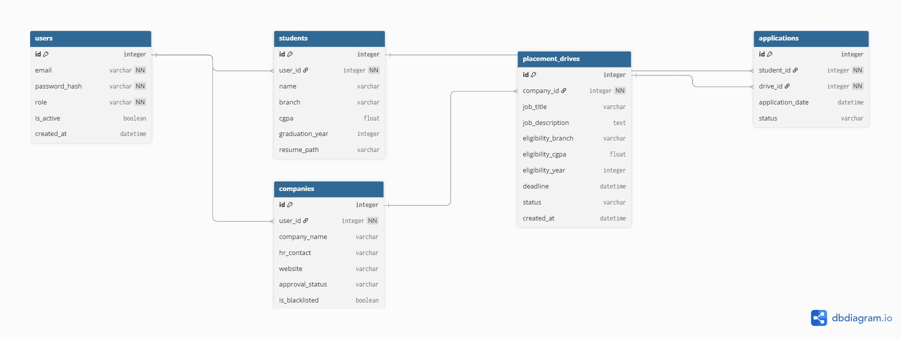

API Resource Endpoints

Authentication
Endpoint | Method | Description
/auth/login | POST | Authenticate user
/auth/register/student | POST | Register student
/auth/register/company | POST | Register company

Admin APIs
Endpoint | Method | Description
/admin/dashboard | GET | Fetch system statistics
/admin/companies | GET | List registered companies
/admin/approve-company/{id} | POST | Approve company
/admin/drives | GET | View placement drives
/admin/approve-drive/{id} | POST | Approve drive

Company APIs
Endpoint | Method | Description
/company/create-drive | POST | Create placement drive
/company/my-drives | GET | View company drives
/company/update-application-status | POST | Update candidate status

Student APIs
Endpoint | Method | Description
/student/drives | GET | View available drives
/student/apply-drive/{id} | POST | Apply for job
/student/my-applications | GET | Track applications

Architecture and Features

System Architecture
The system follows a separated frontend–backend architecture.

Backend (Flask)
Handles authentication, business logic, and database interaction.
Main modules:
- models – database entities
- routes – API endpoints
- services – business logic
- cache – Redis caching
- jobs – background tasks

Frontend (Vue.js)
Provides user interface and communicates with backend APIs.
Main modules:
- components – reusable UI components
- views – pages for each user role
- stores – Pinia state management
- services – API communication

Implemented Features

Authentication
- JWT-based authentication
- Role-based access control

Admin Features
- Approve or reject companies
- Approve placement drives
- View system analytics dashboard

Company Features
- Create placement drives
- View applicants
- Update candidate status

Student Features
- Browse eligible drives
- Apply for placement drives
- Track application status

Analytics
- Dashboard charts using Chart.js for system statistics. Caching
- Redis caching for frequently accessed data like drive listings and dashboard statistics.

Background Tasks
- Automated reminders for upcoming deadlines
- Export application data as CSV
- Monthly placement statistics reports

Video Presentation
Drive Link:
https://drive.google.com/file/d/1fdltVSXFauxkT4ChnxFlUWcAJLPZy2-e/view?usp=sharing
The video demonstrates the system workflow including login, drive creation, application submission, and dashboard analytics.

